# CS 305 Project One Template

## Document Revision History

| **Version** | **Date** | **Author** | **Comments** |
| --- | --- | --- | --- |
| **1.0** | **June 02, 2024** | **Kenneth Wilkerson** |  |

## Client



## Instructions

Submit this completed vulnerability assessment report. Replace the bracketed text with the relevant information. In this report, identify your security vulnerability findings and recommend the next steps to remedy the issues you have found.

* Respond to the five steps outlined below and include your findings.
* Respond using your own words. You may also include images or supporting materials. If you include them, make certain to insert them in the relevant locations in the document.
* Refer to the Project One Guidelines and Rubric for more detailed instructions about each section of the template.

## Developer

Kenneth Wilkerson

**1. Interpreting Client Needs**

Determine your client’s needs and potential threats and attacks associated with the company’s application and software security requirements. Consider the following questions regarding how companies protect against external threats based on the scenario information:

* What is the value of secure communications to the company?

Secure communication is critical to Artemis Financial for several reasons. Secure communication protects the customers data such as name, address, phone number, social security, as well as any account information. Users rely on being able to trust a company to protect its data from unauthorized access and usage. This is also important to the company because there are laws that relate to user data that have to be followed. Data breaches are very costly to a company in terms of monetary damage as well as the user trust thats broken and could take a long time to repair.

* Are there any international transactions that the company produces?

Artemis Financial develops financial plans for its users such as savings, retirement, investments and insurance. This means that transactions could be both national and international.

* Are there governmental restrictions on secure communications to consider?

There are government laws that Artemis Financial should be in compliance with at the launch of their application. One law is PCI-DSS which deals with credit card management. The law outlines which pieces of credit card information can be saved and the encryption mechanisms that need to be in place when that data is communicated throughout the network. Another law would be Gramm-Leach-Bliley which deals with financial information management. The law states that companies have to disclose their information starting operations and protect user data. The client also needs to be aware of strict privacy laws in regions such as the EU which relate to protecting user data.

* What external threats might be present now and in the immediate future?

Artemis Financial faces external threats such as ransomware attacks, malware, denial of service attacks, and the risk of a data breach.

* What modernization requirements must be considered, such as the role of open-source libraries and evolving web application technologies?

All open source libraries should be updated and maintained so that the application can benefit from the most up to date security patches which will enhance the overall security of the application. Artemis Financial might benefit from using a cloud based service which could scale with their operations as they grow and they can benefit from the security mechanisms that are in place in a cloud based system. With the advancement of mobile devices and the usage of biometric data (such as fingerprints and Face ID with Apple devices), Artemis Financial might also consider increasing authentication mechanisms to enhance security.

**2. Areas of Security**

Refer to the vulnerability assessment process flow diagram. Identify which areas of security apply to Artemis Financial’s software application. Justify your reasoning for why each area is relevant to the software application.

The relevant areas of security for Artemis Financial’s application are API’s (secure API interactions), input validation (secure input and representations) and code error.

API’s define the data structures that an application works with. It is important to have up to date frameworks and libraries so that attackers can’t use known vulnerabilities to attack an application. Using up to date frameworks and libraries means that the RESTful API gains all of the benefits of the improved security features.

Input validation is a critical measure to protect against various types of attacks. The process of input validation is making sure that data that is input from external sources or from the user is acceptable for the application. This is important because it helps prevent SQL injection attacks where malicious inputs are used to cause damage. It can also help to mitigate denial of service attacks through limiting input size. Furthermore, It is also more important to take a proactive approach by implementing whitelisting as opposed to resorting to blacklisting.

Code Error is important to the secure coding of this application because issues such as unhandled exceptions can lead the application to behave in unexpected ways which would leave room for attackers to execute malicious code or gain unauthorized access to sensitive data. Managing code error also improves the response when it comes to maintaining the application. It also make the application more stable overall.

**3. Manual Review**

Continue working through the vulnerability assessment process flow diagram. Identify all vulnerabilities in the code base by manually inspecting the code.

Through my review of the pom.xml file, I noticed two issues. The Spring Boot Starter Parent that is used is an outdated version. Specifically, version 2.2.4 is being used in this application on line 8. The other issue is the version of Java being used. The application uses Java version 1.8 on line 18 which is also outdated.

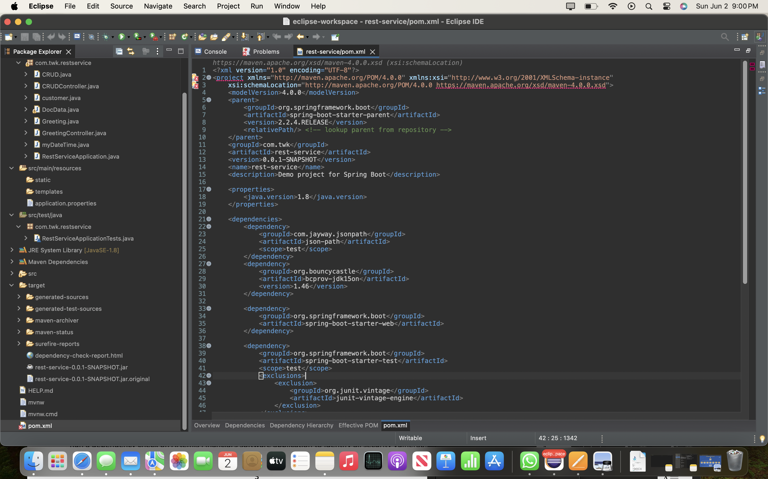

In myDateTime. Java, there is an input validation issue with the setMyDateTime method on lines 14-16. There program does not make sure that hours, minutes and seconds are within appropriate bounds.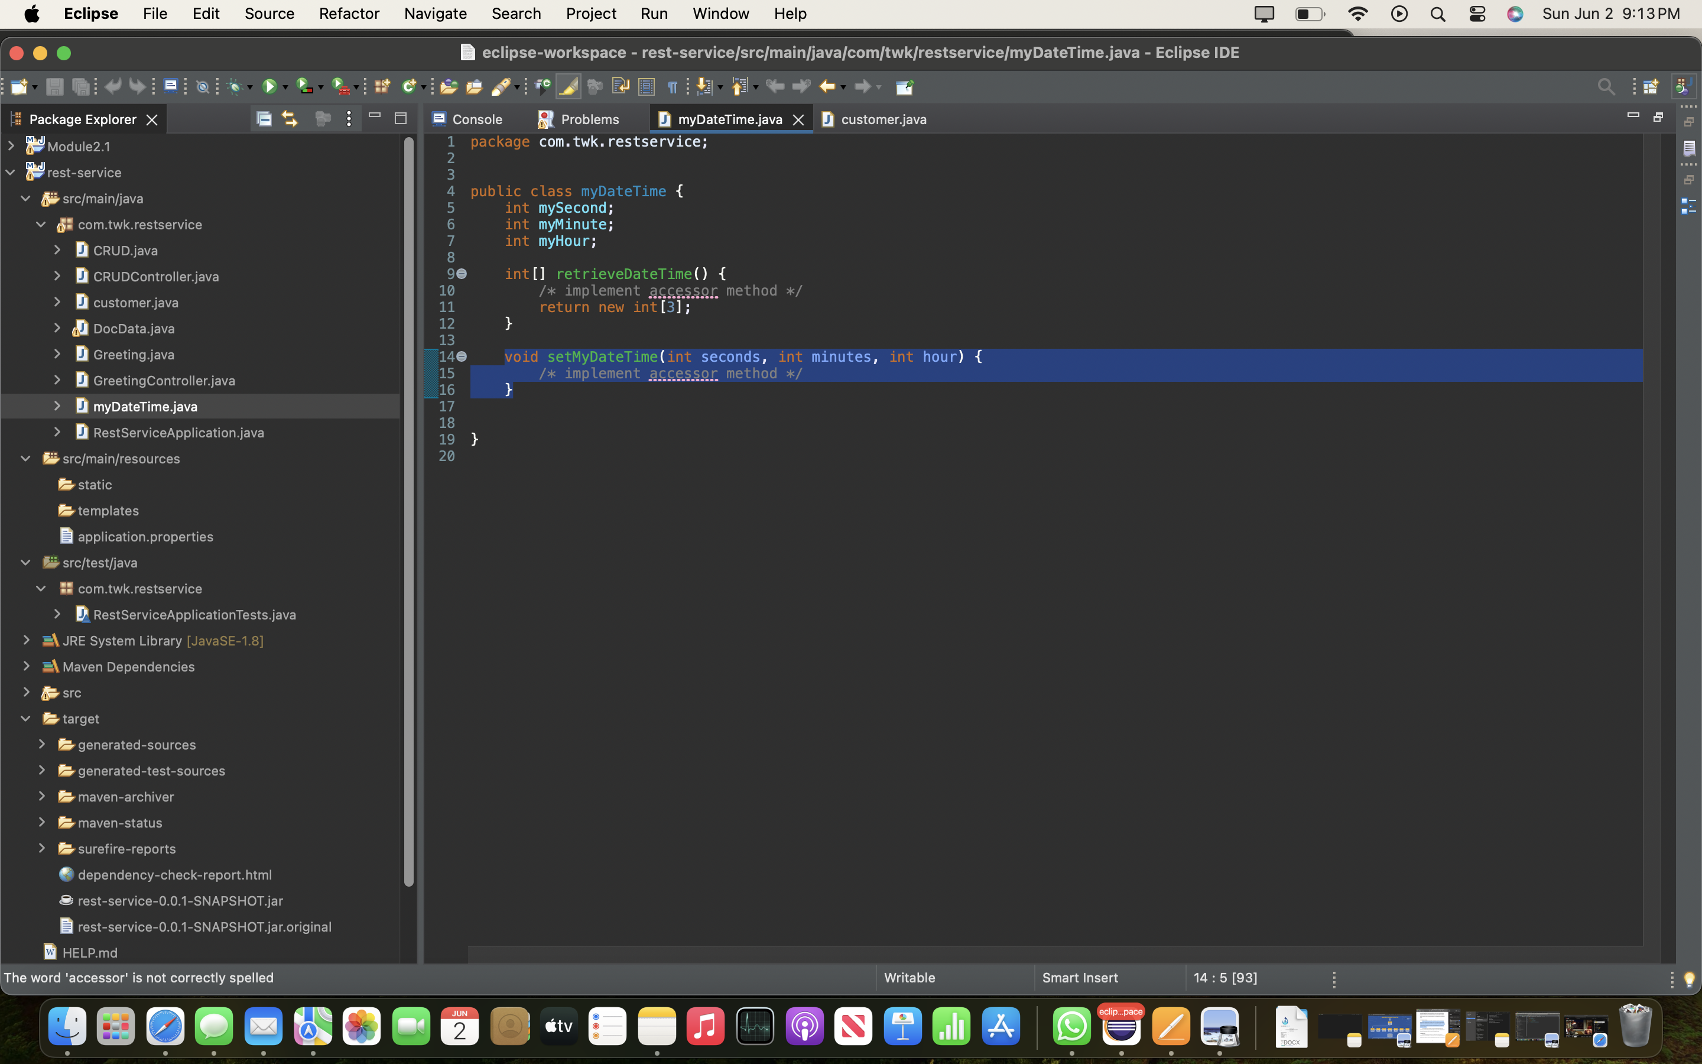

In customer.Java, there is an input validation issue in the deposit method on lines 12-14. The application does not make sure that the deposit is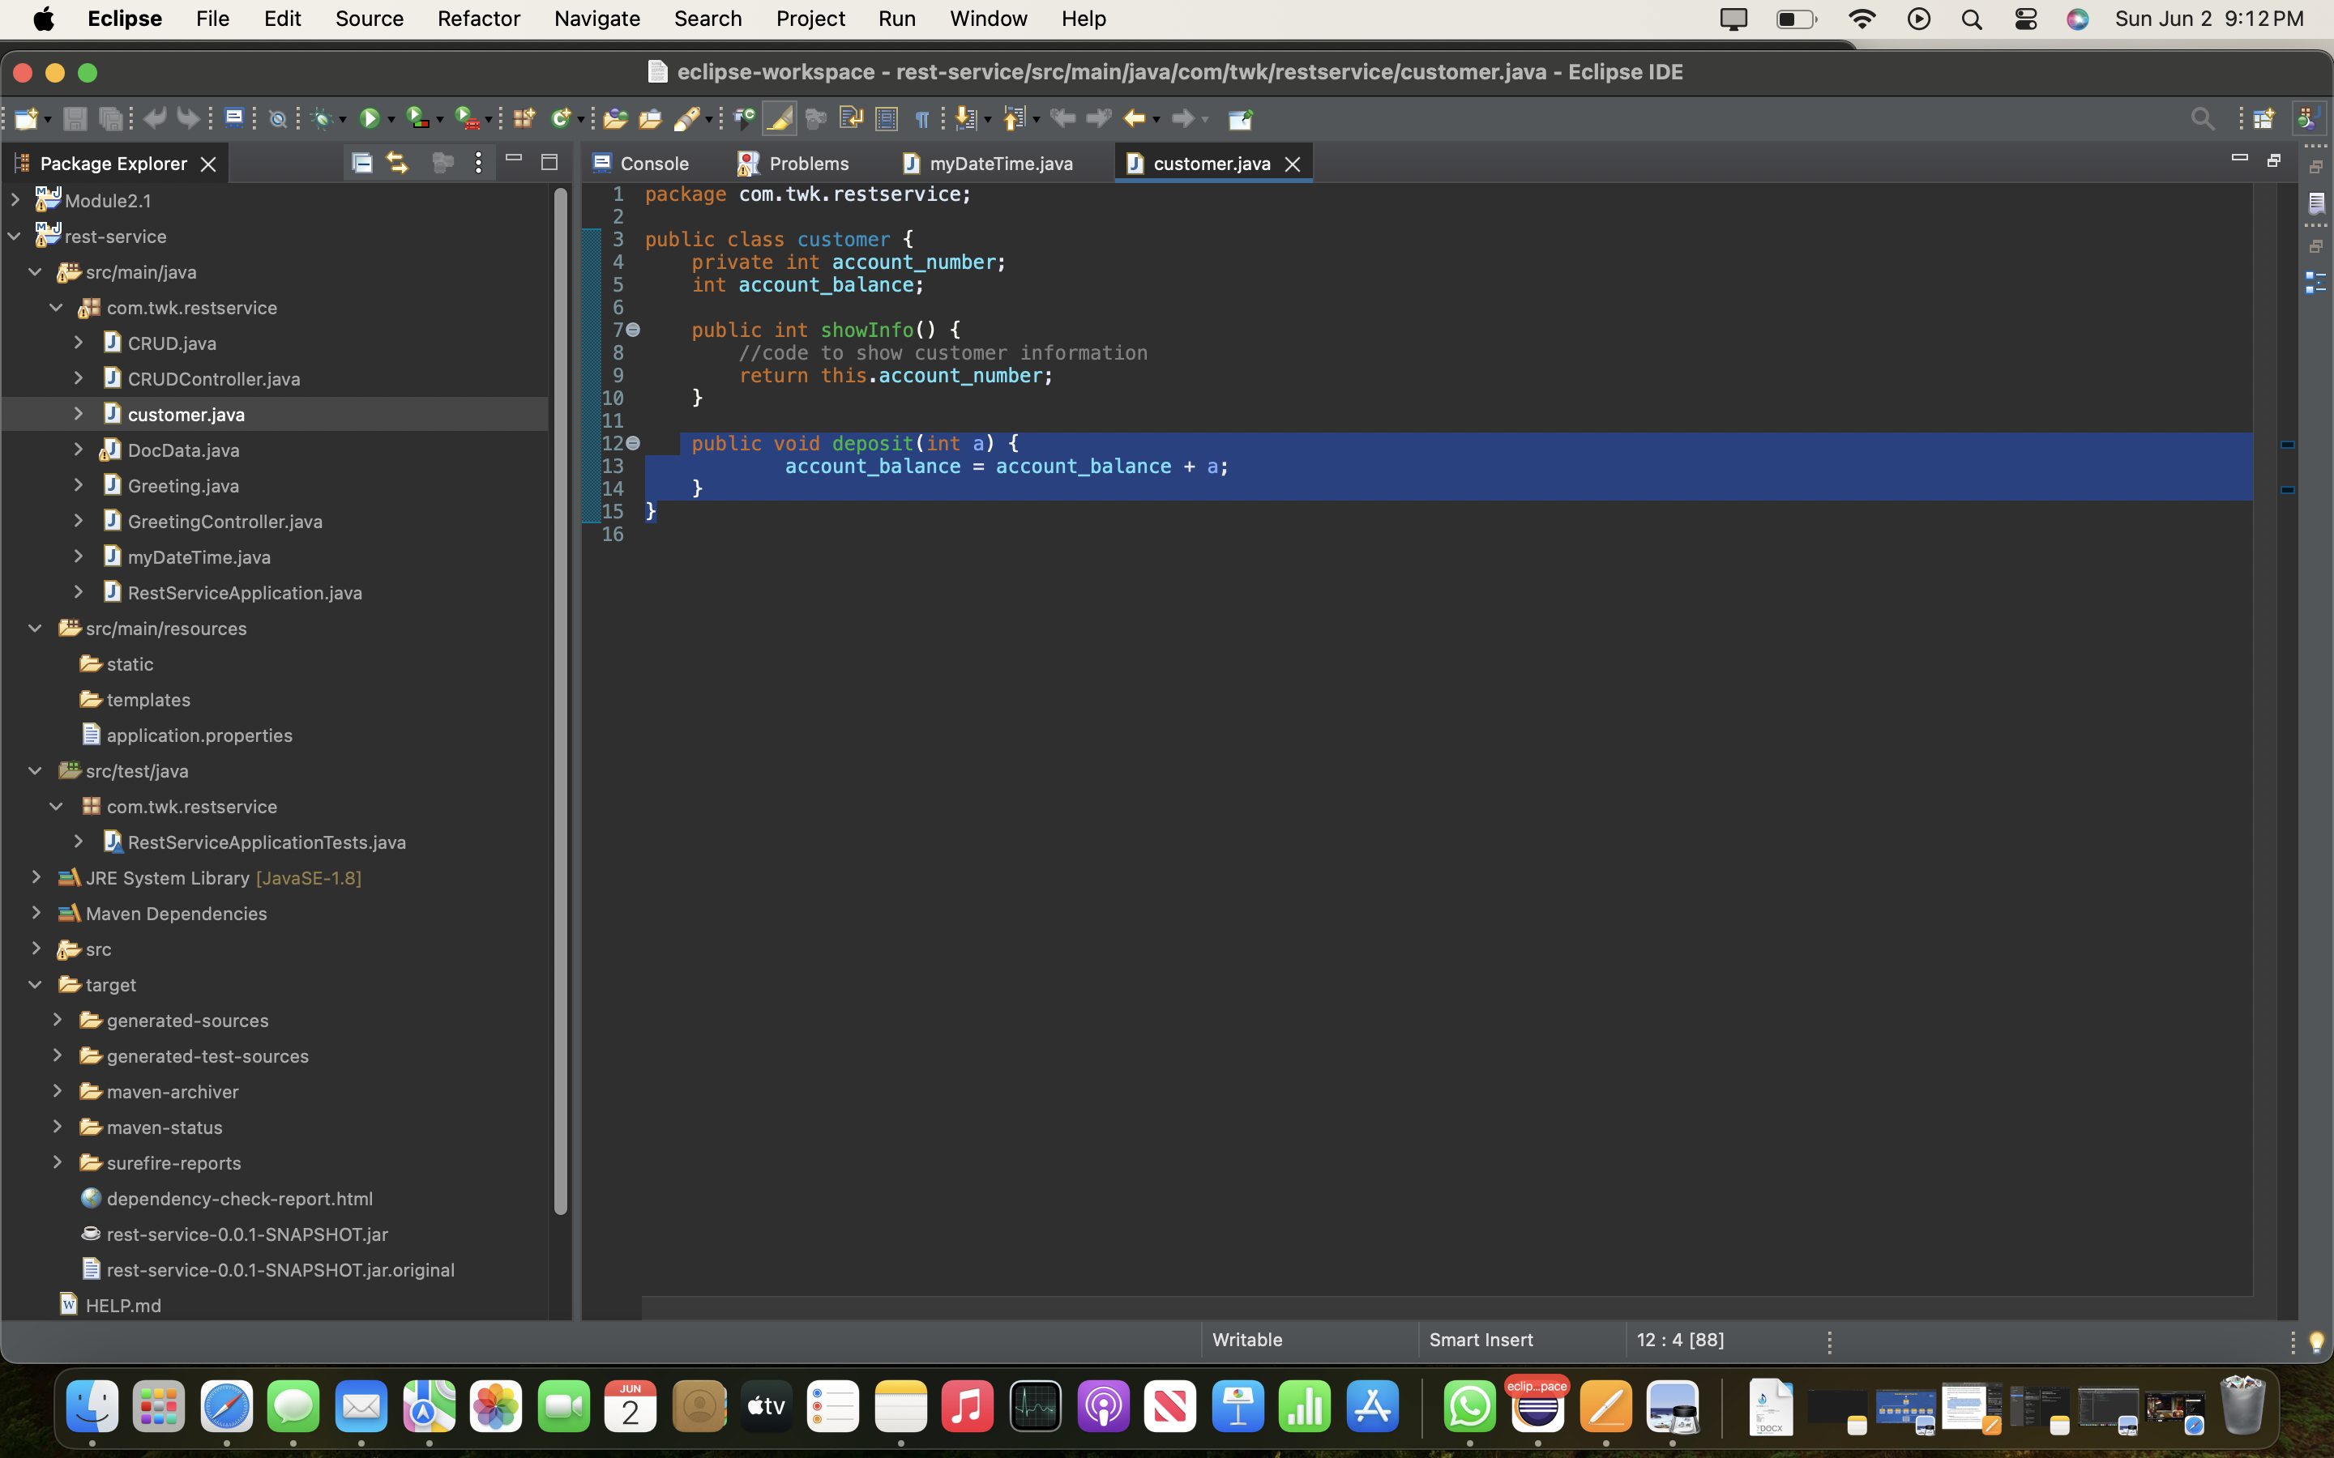 not negative or zero.

In CRUD.Java, in the CRUD methods on lines 7-9 and 12-14 there is not a limit on the string size of the parameters that are used to initialize private fields.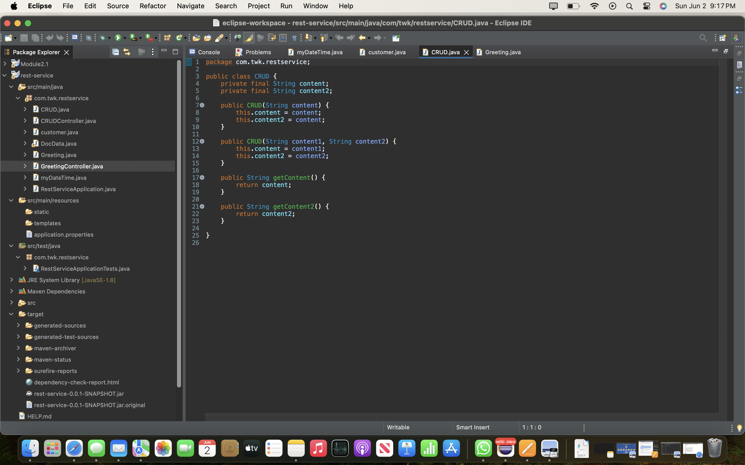

In Greeting.Java, the greeting method on lines 7-10 does not place a limit on the string size of the parameter used to initialize a private field.

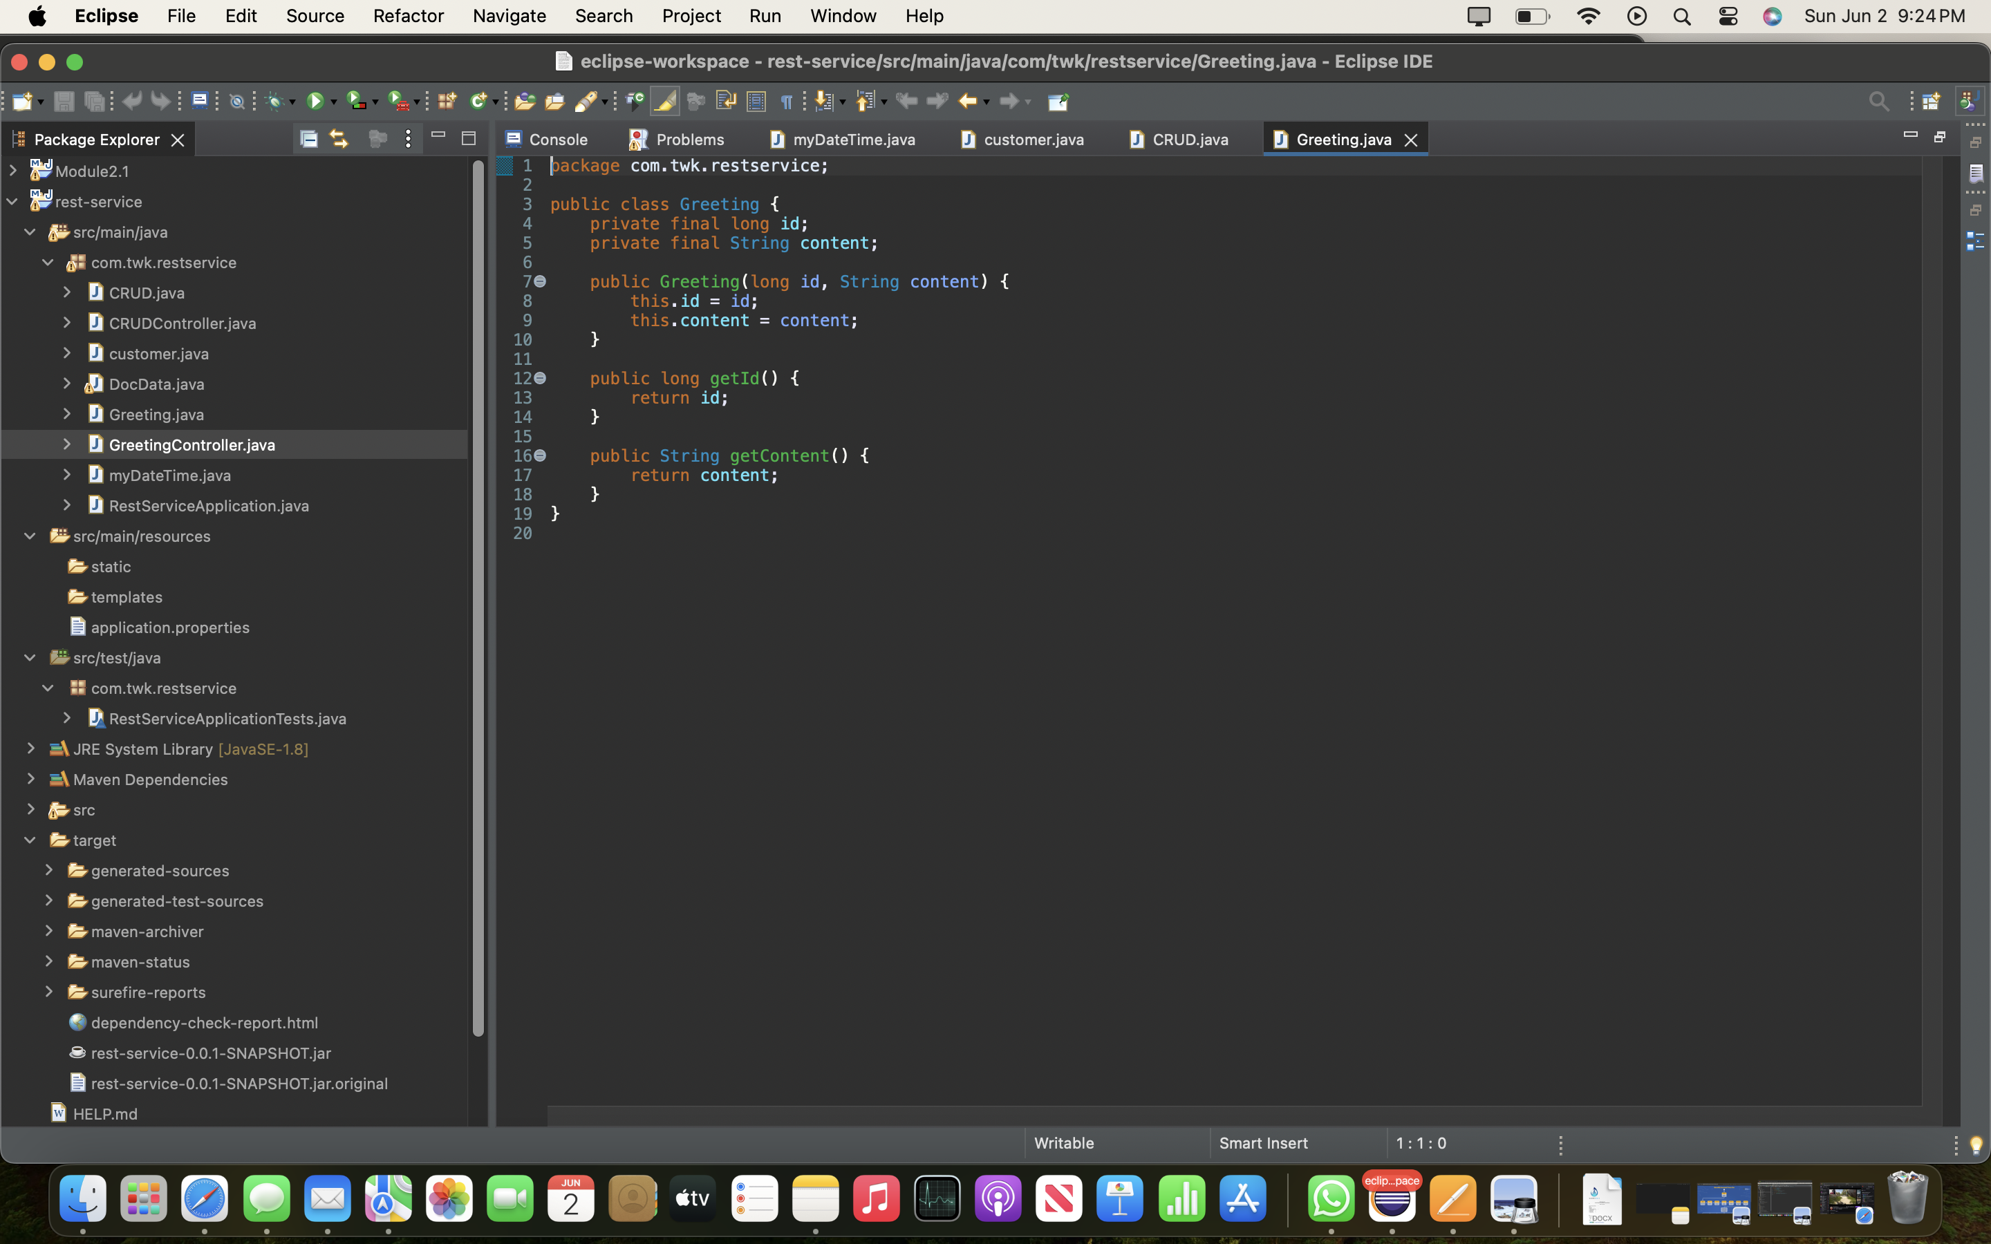

In CRUDcontroller. Java, there is no exception handling in the CRUD method on lines 13-17.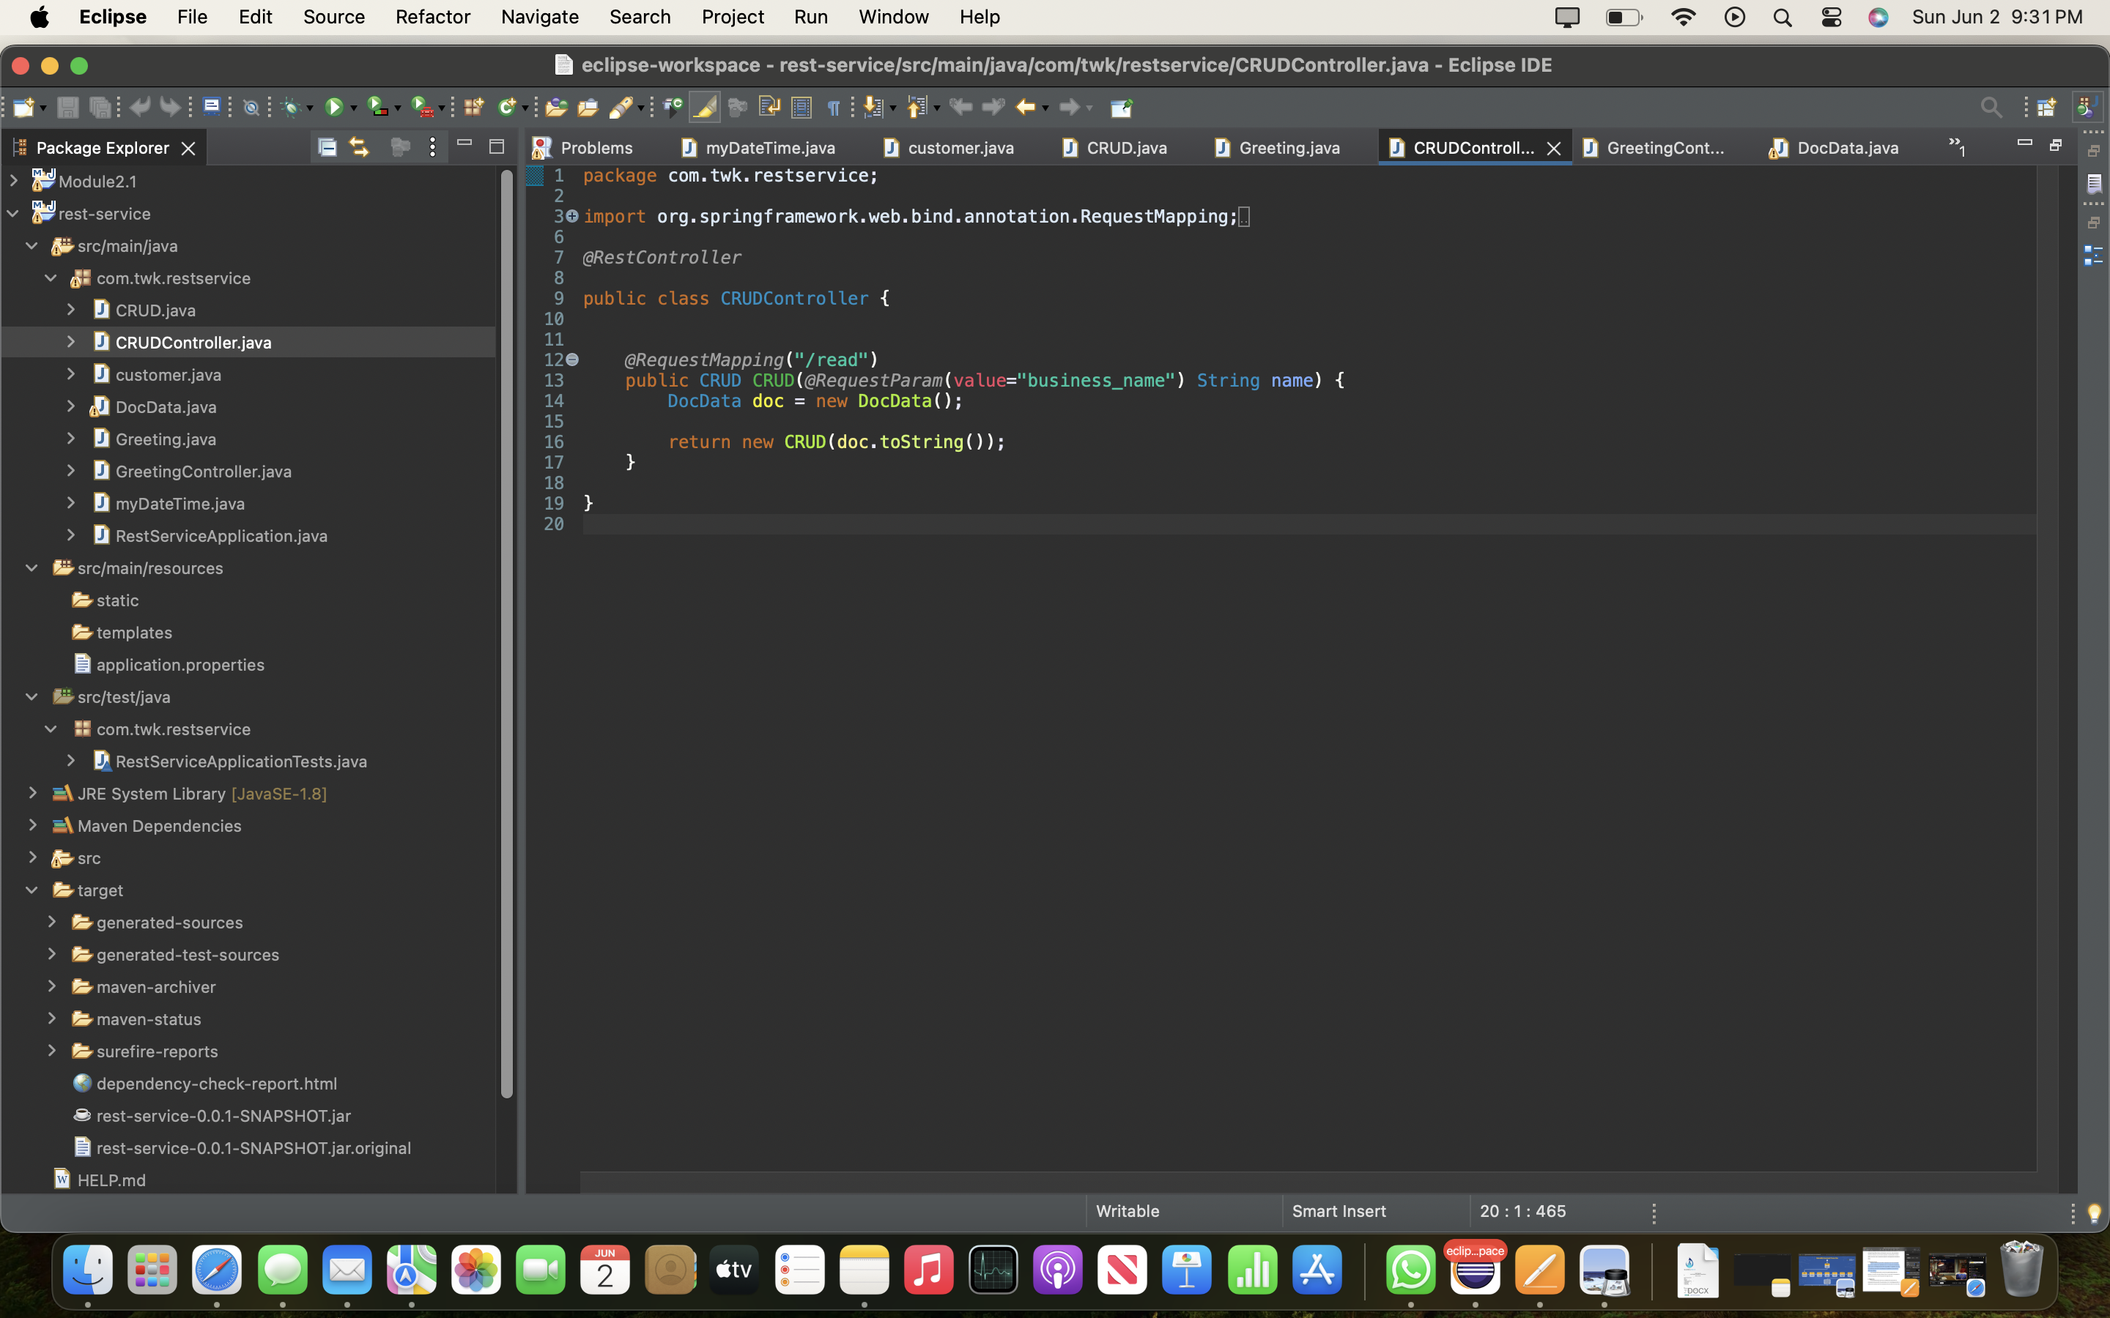

**4. Static Testing**

Run a dependency check on Artemis Financial’s software application to identify all security vulnerabilities in the code. Record the output from the dependency-check report. Include the following items:

* The names or vulnerability codes of the known vulnerabilities
* A brief description and recommended solutions provided by the dependency-check report
* Any attribution that documents how this vulnerability has been identified or documented previously

|  |  |  |  |  |
| --- | --- | --- | --- | --- |
| Dependency | Highest  Severity | CVE Count | Confidence | Evidence  Count |
| bcprov-jdk15on-1.46.jar | High | 22 | Highest | 38 |
| hibernate-validator-6.0.18.Final.jar | Medium | 1 | Highest | 32 |
| jackson-databind-2.10.2.jar | High | 6 | Highest | 39 |
| log4j-api-2.12.1.jar | Low | 1 | Highest | 42 |
| logback-core-1.2.3.jar | High | 2 | Highest | 31 |
| snakeyaml-1.25.jar | Critical | 8 | Highest | 44 |
| spring-boot-2.2.4.RELEASE.jar | Critical | 3 | Highest | 39 |
| spring-boot-starter-web-2.2.4.RELEASE.jar | Critical | 3 | Highest | 35 |
| spring-core-5.2.3.RELEASE.jar | Critical | 11 | Highest | 36 |
| spring-web-5.2.3.RELEASE.jar | Critical | 14 | Highest | 34 |
| spring-webmvc-5.2.3.RELEASE.jar | Critical | 11 | Highest | 36 |
| tomcat-embed-core-9.0.30.jar | Critical | 26 | Highest | 30 |
| tomcat-embed-websocket-9.0.30.jar | Critical | 27 | Highest | 30 |

|  |  |  |
| --- | --- | --- |
| Dependency | CVE ID | Description |
| bcprov-jdk15on-1.46.jar | **CVE-2024-34447** (OSSINDEX) | bouncycastle - Improper Validation of Certificate with Host Mismatch  The software communicates with a host that provides a certificate, but the software does not properly ensure that the certificate is actually associated with that host. |
|  | [CVE-2016-1000338](https://web.nvd.nist.gov/view/vuln/detail?vulnId=CVE-2016-1000338) | In Bouncy Castle JCE Provider version 1.55 and earlier the DSA does not fully validate ASN.1 encoding of signature on verification. It is possible to inject extra elements in the sequence making up the signature and still have it validate, which in some cases may allow the introduction of 'invisible' data into a signed structure. |
|  | **CVE-2016-1000342** | In the Bouncy Castle JCE Provider version 1.55 and earlier ECDSA does not fully validate ASN.1 encoding of signature on verification. It is possible to inject extra elements in the sequence making up the signature and still have it validate, which in some cases may allow the introduction of 'invisible' data into a signed structure. |
|  | **CVE-2016-1000343** | In the Bouncy Castle JCE Provider version 1.55 and earlier the DSA key pair generator generates a weak private key if used with default values. If the JCA key pair generator is not explicitly initialised with DSA parameters, 1.55 and earlier generates a private value assuming a 1024 bit key size. In earlier releases this can be dealt with by explicitly passing parameters to the key pair generator. |
|  | **CVE-2024-29857** (OSSINDEX) | An issue was discovered in ECCurve.java and ECCurve.cs in Bouncy Castle Java (BC Java) before 1.78, BC Java LTS before 2.73.6, BC-FJA before 1.0.2.5, and BC C# .Net before 2.3.1. Importing an EC certificate with crafted F2m parameters can lead to excessive CPU consumption during the evaluation of the curve parameters. |
|  | **CVE-2016-1000344** | In the Bouncy Castle JCE Provider version 1.55 and earlier the DHIES implementation allowed the use of ECB mode. This mode is regarded as unsafe and support for it has been removed from the provider. |
|  | [CVE-2016-1000352](https://web.nvd.nist.gov/view/vuln/detail?vulnId=CVE-2016-1000352) | In the Bouncy Castle JCE Provider version 1.55 and earlier the ECIES implementation allowed the use of ECB mode. This mode is regarded as unsafe and support for it has been removed from the provider. |
|  | **CVE-2024-30171** (OSSINDEX) | An issue was discovered in Bouncy Castle Java TLS API and JSSE Provider before 1.78. Timing-based leakage may occur in RSA based handshakes because of exception processing. |
|  | **CVE-2016-1000341** | In the Bouncy Castle JCE Provider version 1.55 and earlier DSA signature generation is vulnerable to timing attack. Where timings can be closely observed for the generation of signatures, the lack of blinding in 1.55, or earlier, may allow an attacker to gain information about the signature's k value and ultimately the private value as well. |
|  | [CVE-2016-1000345](https://web.nvd.nist.gov/view/vuln/detail?vulnId=CVE-2016-1000345) | In the Bouncy Castle JCE Provider version 1.55 and earlier the DHIES/ECIES CBC mode vulnerable to padding oracle attack. For BC 1.55 and older, in an environment where timings can be easily observed, it is possible with enough observations to identify when the decryption is failing due to padding. |
|  | **CVE-2017-13098** | BouncyCastle TLS prior to version 1.0.3, when configured to use the JCE (Java Cryptography Extension) for cryptographic functions, provides a weak Bleichenbacher oracle when any TLS cipher suite using RSA key exchange is negotiated. An attacker can recover the private key from a vulnerable application. This vulnerability is referred to as "ROBOT." |
|  | **CVE-2020-15522** | Bouncy Castle BC Java before 1.66, BC C# .NET before 1.8.7, BC-FJA before 1.0.1.2, 1.0.2.1, and BC-FNA before 1.0.1.1 have a timing issue within the EC math library that can expose information about the private key when an attacker is able to observe timing information for the generation of multiple deterministic ECDSA signatures. |
|  | **CVE-2020-0187** (OSSINDEX) | In engineSetMode of BaseBlockCipher.java, there is a possible incorrect cryptographic algorithm chosen due to an incomplete comparison. This could lead to local information disclosure with no additional execution privileges needed. User interaction is not needed for exploitation.Product: AndroidVersions: Android-10Android ID: A-148517383 |
|  | **CVE-2023-33202** | Bouncy Castle for Java before 1.73 contains a potential Denial of Service (DoS) issue within the Bouncy Castle org.bouncycastle.openssl.PEMParser class. This class parses OpenSSL PEM encoded streams containing X.509 certificates, PKCS8 encoded keys, and PKCS7 objects. Parsing a file that has crafted ASN.1 data through the PEMParser causes an OutOfMemoryError, which can enable a denial of service attack. (For users of the FIPS Java API: BC-FJA 1.0.2.3 and earlier are affected; BC-FJA 1.0.2.4 is fixed.) |
|  | **CVE-2020-26939** (OSSINDEX) | In Legion of the Bouncy Castle BC before 1.61 and BC-FJA before 1.0.1.2, attackers can obtain sensitive information about a private exponent because of Observable Differences in Behavior to Error Inputs. This occurs in org.bouncycastle.crypto.encodings.OAEPEncoding. Sending invalid ciphertext that decrypts to a short payload in the OAEP Decoder could result in the throwing of an early exception, potentially leaking some information about the private exponent of the RSA private key performing the encryption. |
|  | **CVE-2023-33201** (OSSINDEX) | Bouncy Castle For Java before 1.74 is affected by an LDAP injection vulnerability. The vulnerability only affects applications that use an LDAP CertStore from Bouncy Castle to validate X.509 certificates. During the certificate validation process, Bouncy Castle inserts the certificate's Subject Name into an LDAP search filter without any escaping, which leads to an LDAP injection vulnerability. |
|  | **CVE-2016-1000339** | In the Bouncy Castle JCE Provider version 1.55 and earlier the primary engine class used for AES was AESFastEngine. Due to the highly table driven approach used in the algorithm it turns out that if the data channel on the CPU can be monitored the lookup table accesses are sufficient to leak information on the AES key being used. There was also a leak in AESEngine although it was substantially less. AESEngine has been modified to remove any signs of leakage (testing carried out on Intel X86-64) and is now the primary AES class for the BC JCE provider from 1.56. Use of AESFastEngine is now only recommended where otherwise deemed appropriate. |
|  | **CVE-2015-7940** | The Bouncy Castle Java library before 1.51 does not validate a point is withing the elliptic curve, which makes it easier for remote attackers to obtain private keys via a series of crafted elliptic curve Diffie Hellman (ECDH) key exchanges, aka an "invalid curve attack." |
|  | **CVE-2018-5382** | The default BKS keystore use an HMAC that is only 16 bits long, which can allow an attacker to compromise the integrity of a BKS keystore. Bouncy Castle release 1.47 changes the BKS format to a format which uses a 160 bit HMAC instead. This applies to any BKS keystore generated prior to BC 1.47. For situations where people need to create the files for legacy reasons a specific keystore type "BKS-V1" was introduced in 1.49. It should be noted that the use of "BKS-V1" is discouraged by the library authors and should only be used where it is otherwise safe to do so, as in where the use of a 16 bit checksum for the file integrity check is not going to cause a security issue in itself. |
|  | **CVE-2013-1624** | The TLS implementation in the Bouncy Castle Java library before 1.48 and C# library before 1.8 does not properly consider timing side-channel attacks on a noncompliant MAC check operation during the processing of malformed CBC padding, which allows remote attackers to conduct distinguishing attacks and plaintext-recovery attacks via statistical analysis of timing data for crafted packets, a related issue to CVE-2013-0169. |
|  | CVE-2016-1000346 | In the Bouncy Castle JCE Provider version 1.55 and earlier the other party DH public key is not fully validated. This can cause issues as invalid keys can be used to reveal details about the other party's private key where static Diffie-Hellman is in use. As of release 1.56 the key parameters are checked on agreement calculation. |
|  | **CVE-2015-6644** (OSSINDEX) | Bouncy Castle in Android before 5.1.1 LMY49F and 6.0 before 2016-01-01 allows attackers to obtain sensitive information via a crafted application, aka internal bug 24106146. |
| hibernate-validator-6.0.18.Final.jar | **CVE-2020-10693** | A flaw was found in Hibernate Validator version 6.1.2.Final. A bug in the message interpolation processor enables invalid EL expressions to be evaluated as if they were valid. This flaw allows attackers to bypass input sanitation (escaping, stripping) controls that developers may have put in place when handling user-controlled data in error messages. |
| jackson-databind-2.10.2.jar | **CVE-2020-25649** | A flaw was found in FasterXML Jackson Databind, where it did not have entity expansion secured properly. This flaw allows vulnerability to XML external entity (XXE) attacks. The highest threat from this vulnerability is data integrity. |
|  | **CVE-2020-36518** | jackson-databind before 2.13.0 allows a Java StackOverflow exception and denial of service via a large depth of nested objects. |
|  | **CVE-2021-46877** | jackson-databind 2.10.x through 2.12.x before 2.12.6 and 2.13.x before 2.13.1 allows attackers to cause a denial of service (2 GB transient heap usage per read) in uncommon situations involving JsonNode JDK serialization. |
|  | **CVE-2022-42003** | In FasterXML jackson-databind before versions 2.13.4.1 and 2.12.17.1, resource exhaustion can occur because of a lack of a check in primitive value deserializers to avoid deep wrapper array nesting, when the UNWRAP_SINGLE_VALUE_ARRAYS feature is enabled. |
|  | **CVE-2022-42004** | In FasterXML jackson-databind before 2.13.4, resource exhaustion can occur because of a lack of a check in BeanDeserializer._deserializeFromArray to prevent use of deeply nested arrays. An application is vulnerable only with certain customized choices for deserialization. |
|  | **CVE-2023-35116** | jackson-databind through 2.15.2 allows attackers to cause a denial of service or other unspecified impact via a crafted object that uses cyclic dependencies. NOTE: the vendor's perspective is that this is not a valid vulnerability report, because the steps of constructing a cyclic data structure and trying to serialize it cannot be achieved by an external attacker. |
| log4j-api-2.12.1.jar | **CVE-2020-9488** | Improper validation of certificate with host mismatch in Apache Log4j SMTP appender. This could allow an SMTPS connection to be intercepted by a man-in-the-middle attack which could leak any log messages sent through that appender. Fixed in Apache Log4j 2.12.3 and 2.13.1 |
| logback-core-1.2.3.jar | **CVE-2023-6378** | A serialization vulnerability in logback receiver component part of  logback version 1.4.11 allows an attacker to mount a Denial-Of-Service  attack by sending poisoned data. |
|  | **CVE-2021-42550** | In logback version 1.2.7 and prior versions, an attacker with the required privileges to edit configurations files could craft a malicious configuration allowing to execute arbitrary code loaded from LDAP servers. |
| snakeyaml-1.25.jar | **CVE-2022-147** | SnakeYaml's Constructor() class does not restrict types which can be instantiated during deserialization.Deserializing yaml content provided by an attacker can lead to remote code execution. We recommend using SnakeYaml's SafeConsturctor when parsing untrusted content to restrict deserialization. We recommend upgrading to version 2.0 and beyond. |
|  | **CVE-2017-18640** | The Alias feature in SnakeYAML before 1.26 allows entity expansion during a load operation, a related issue to CVE-2003-1564. |
|  | **CVE-2022-25857** | The package org.yaml:snakeyaml from 0 and before 1.31 are vulnerable to Denial of Service (DoS) due missing to nested depth limitation for collections. |
|  | **CVE-2022-38749** | Using snakeYAML to parse untrusted YAML files may be vulnerable to Denial of Service attacks (DOS). If the parser is running on user supplied input, an attacker may supply content that causes the parser to crash by stackoverflow. |
|  | [CVE-2022-38751](https://web.nvd.nist.gov/view/vuln/detail?vulnId=CVE-2022-38751) | Using snakeYAML to parse untrusted YAML files may be vulnerable to Denial of Service attacks (DOS). If the parser is running on user supplied input, an attacker may supply content that causes the parser to crash by stackoverflow. |
|  | **CVE-2022-38752** | Using snakeYAML to parse untrusted YAML files may be vulnerable to Denial of Service attacks (DOS). If the parser is running on user supplied input, an attacker may supply content that causes the parser to crash by stack-overflow. |
|  | **CVE-2022-41854** | Those using Snakeyaml to parse untrusted YAML files may be vulnerable to Denial of Service attacks (DOS). If the parser is running on user supplied input, an attacker may supply content that causes the parser to crash by stack overflow. This effect may support a denial of service attack. |
|  | **CVE-2022-38750** | Using snakeYAML to parse untrusted YAML files may be vulnerable to Denial of Service attacks (DOS). If the parser is running on user supplied input, an attacker may supply content that causes the parser to crash by stackoverflow. |
| **spring-boot-2.2.4.RELEASE.jar** | CVE-2023-20873 | In Spring Boot versions 3.0.0 - 3.0.5, 2.7.0 - 2.7.10, and older unsupported versions, an application that is deployed to Cloud Foundry could be susceptible to a security bypass. Users of affected versions should apply the following mitigation: 3.0.x users should upgrade to 3.0.6+. 2.7.x users should upgrade to 2.7.11+. Users of older, unsupported versions should upgrade to 3.0.6+ or 2.7.11+. |
|  | **CVE-2022-27772** | spring-boot versions prior to version v2.2.11.RELEASE was vulnerable to temporary directory hijacking. This vulnerability impacted the org.springframework.boot.web.server.AbstractConfigurableWebServerFactory.createTempDir method. NOTE: This vulnerability only affects products and/or versions that are no longer supported by the maintainer |
|  | [CVE-2023-20883](https://web.nvd.nist.gov/view/vuln/detail?vulnId=CVE-2023-20883) | In Spring Boot versions 3.0.0 - 3.0.6, 2.7.0 - 2.7.11, 2.6.0 - 2.6.14, 2.5.0 - 2.5.14 and older unsupported versions, there is potential for a denial-of-service (DoS) attack if Spring MVC is used together with a reverse proxy cache. |
| **spring-core-5.2.3.RELEASE.jar** | **CVE-2022-22965** | Spring MVC or Spring WebFlux application running on JDK 9+ may be vulnerable to remote code execution (RCE) via data binding. |
|  | **CVE-2021-22118** | In Spring Framework, versions 5.2.x prior to 5.2.15 and versions 5.3.x prior to 5.3.7, a WebFlux application is vulnerable to a privilege escalation: by (re)creating the temporary storage directory, a locally authenticated malicious user can read or modify files that have been uploaded to the WebFlux application, or overwrite arbitrary files with multipart request data. |
|  | **CVE-2020-5421** | In Spring Framework versions 5.2.0 - 5.2.8, 5.1.0 - 5.1.17, 5.0.0 - 5.0.18, 4.3.0 - 4.3.28, and older unsupported versions, the protections against RFD attacks from CVE-2015-5211 may be bypassed depending on the browser used through the use of a jsessionid path parameter. |
|  | **CVE-2022-22950** | In Spring Framework versions 5.3.0 - 5.3.16 and older unsupported versions, it is possible for a user to provide a specially crafted SpEL expression that may cause a denial of service condition. |
|  | **CVE-2022-2297** | In spring framework versions prior to 5.3.20+ , 5.2.22+ and old unsupported versions, application with a STOMP over WebSocket endpoint is vulnerable to a denial of service attack by an authenticated user. |
|  | **CVE-2023-20861** | In Spring Framework versions 6.0.0 - 6.0.6, 5.3.0 - 5.3.25, 5.2.0.RELEASE - 5.2.22.RELEASE, and older unsupported versions, it is possible for a user to provide a specially crafted SpEL expression that may cause a denial-of-service (DoS) condition. |
|  | **CVE-2023-20863** | In spring framework versions prior to 5.2.24 release+ ,5.3.27+ and 6.0.8+ , it is possible for a user to provide a specially crafted SpEL expression that may cause a denial-of-service (DoS) condition. |
|  | **CVE-2022-22968** | In Spring Framework versions 5.3.0 - 5.3.18, 5.2.0 - 5.2.20, and older unsupported versions, the patterns for disallowedFields on a DataBinder are case sensitive which means a field is not effectively protected unless it is listed with both upper and lower case for the first character of the field, including upper and lower case for the first character of all nested fields within the property path. |
|  | **CVE-2022-22970** | In spring framework versions prior to 5.3.20+ , 5.2.22+ and old unsupported versions, applications that handle file uploads are vulnerable to DoS attack if they rely on data binding to set a MultipartFile or javax.servlet.Part to a field in a model object. |
|  | **CVE-2021-22060** | In Spring Framework versions 5.3.0 - 5.3.13, 5.2.0 - 5.2.18, and older unsupported versions, it is possible for a user to provide malicious input to cause the insertion of additional log entries. This is a follow-up to CVE-2021-22096 that protects against additional types of input and in more places of the Spring Framework codebase. |
|  | **CVE-2021-22096** | In Spring Framework versions 5.3.0 - 5.3.10, 5.2.0 - 5.2.17, and older unsupported versions, it is possible for a user to provide malicious input to cause the insertion of additional log entries. |
| **spring-web-5.2.3.RELEASE.jar** | **CVE-2016-1000027** | Pivotal Spring Framework through 5.3.16 suffers from a potential remote code execution (RCE) issue if used for Java deserialization of untrusted data. Depending on how the library is implemented within a product, this issue may or not occur, and authentication may be required. NOTE: the vendor's position is that untrusted data is not an intended use case. The product's behavior will not be changed because some users rely on deserialization of trusted data. |
|  | **CVE-2022-22965** | Spring MVC or Spring WebFlux application running on JDK 9+ may be vulnerable to remote code execution (RCE) via data binding. |
|  | **CVE-2024-22243** (OSSINDEX) | Applications that use UriComponentsBuilder to parse an externally provided URL (e.g. through a query parameter) AND perform validation checks on the host of the parsed URL may be vulnerable to a open redirect <https://cwe.mitre.org/data/definitions/601.html>  attack or to a SSRF attack if the URL is used after passing validation checks. |
|  | **CVE-2024-22262** (OSSINDEX) | Applications that use UriComponentsBuilder to parse an externally provided URL (e.g. through a query parameter) AND perform validation checks on the host of the parsed URL may be vulnerable to a open redirect <https://cwe.mitre.org/data/definitions/601.html>  attack or to a SSRF attack if the URL is used after passing validation checks. |
|  | **CVE-2021-22118** | In Spring Framework, versions 5.2.x prior to 5.2.15 and versions 5.3.x prior to 5.3.7, a WebFlux application is vulnerable to a privilege escalation: by (re)creating the temporary storage directory, a locally authenticated malicious user can read or modify files that have been uploaded to the WebFlux application, or overwrite arbitrary files with multipart request data. |
|  | **CVE-2020-5421** | In Spring Framework versions 5.2.0 - 5.2.8, 5.1.0 - 5.1.17, 5.0.0 - 5.0.18, 4.3.0 - 4.3.28, and older unsupported versions, the protections against RFD attacks from CVE-2015-5211 may be bypassed depending on the browser used through the use of a jsessionid path parameter. |
|  | **CVE-2022-22950** | In Spring Framework versions 5.3.0 - 5.3.16 and older unsupported versions, it is possible for a user to provide a specially crafted SpEL expression that may cause a denial of service condition. |
|  | **[CVE-2022-22971](https://web.nvd.nist.gov/view/vuln/detail?vulnId=CVE-2022-22971)** | In spring framework versions prior to 5.3.20+ , 5.2.22+ and old unsupported versions, application with a STOMP over WebSocket endpoint is vulnerable to a denial of service attack by an authenticated user. |
|  | **CVE-2023-20861** | In Spring Framework versions 6.0.0 - 6.0.6, 5.3.0 - 5.3.25, 5.2.0.RELEASE - 5.2.22.RELEASE, and older unsupported versions, it is possible for a user to provide a specially crafted SpEL expression that may cause a denial-of-service (DoS) condition. |
|  | **CVE-2023-20863** | In spring framework versions prior to 5.2.24 release+ ,5.3.27+ and 6.0.8+ , it is possible for a user to provide a specially crafted SpEL expression that may cause a denial-of-service (DoS) condition. |
|  | **CVE-2022-22968** | In Spring Framework versions 5.3.0 - 5.3.18, 5.2.0 - 5.2.20, and older unsupported versions, the patterns for disallowedFields on a DataBinder are case sensitive which means a field is not effectively protected unless it is listed with both upper and lower case for the first character of the field, including upper and lower case for the first character of all nested fields within the property path. |
|  | **CVE-2022-22970** | In spring framework versions prior to 5.3.20+ , 5.2.22+ and old unsupported versions, applications that handle file uploads are vulnerable to DoS attack if they rely on data binding to set a MultipartFile or javax.servlet.Part to a field in a model object. |
|  | **CVE-2021-22060** | In Spring Framework versions 5.3.0 - 5.3.13, 5.2.0 - 5.2.18, and older unsupported versions, it is possible for a user to provide malicious input to cause the insertion of additional log entries. This is a follow-up to CVE-2021-22096 that protects against additional types of input and in more places of the Spring Framework codebase. |
|  | **CVE-2021-22096** | In Spring Framework versions 5.3.0 - 5.3.10, 5.2.0 - 5.2.17, and older unsupported versions, it is possible for a user to provide malicious input to cause the insertion of additional log entries. |
| **spring-webmvc-5.2.3.RELEASE.jar** | **CVE-2022-22965** | Spring MVC or Spring WebFlux application running on JDK 9+ may be vulnerable to remote code execution (RCE) via data binding. |
|  | **CVE-2021-22118** | In Spring Framework, versions 5.2.x prior to 5.2.15 and versions 5.3.x prior to 5.3.7, a WebFlux application is vulnerable to a privilege escalation: by (re)creating the temporary storage directory, a locally authenticated malicious user can read or modify files that have been uploaded to the WebFlux application, or overwrite arbitrary files with multipart request data. |
|  | **CVE-2020-5421** | In Spring Framework versions 5.2.0 - 5.2.8, 5.1.0 - 5.1.17, 5.0.0 - 5.0.18, 4.3.0 - 4.3.28, and older unsupported versions, the protections against RFD attacks from CVE-2015-5211 may be bypassed depending on the browser used through the use of a jsessionid path parameter. |
|  | **CVE-2022-22950** | In Spring Framework versions 5.3.0 - 5.3.16 and older unsupported versions, it is possible for a user to provide a specially crafted SpEL expression that may cause a denial of service condition. |
|  | **CVE-2022-2297** | In spring framework versions prior to 5.3.20+ , 5.2.22+ and old unsupported versions, application with a STOMP over WebSocket endpoint is vulnerable to a denial of service attack by an authenticated user. |
|  | **CVE-2023-20861** | In Spring Framework versions 6.0.0 - 6.0.6, 5.3.0 - 5.3.25, 5.2.0.RELEASE - 5.2.22.RELEASE, and older unsupported versions, it is possible for a user to provide a specially crafted SpEL expression that may cause a denial-of-service (DoS) condition. |
|  | **CVE-2023-20863** | In spring framework versions prior to 5.2.24 release+ ,5.3.27+ and 6.0.8+ , it is possible for a user to provide a specially crafted SpEL expression that may cause a denial-of-service (DoS) condition. |
|  | **CVE-2022-22968** | In Spring Framework versions 5.3.0 - 5.3.18, 5.2.0 - 5.2.20, and older unsupported versions, the patterns for disallowedFields on a DataBinder are case sensitive which means a field is not effectively protected unless it is listed with both upper and lower case for the first character of the field, including upper and lower case for the first character of all nested fields within the property path. |
|  | **CVE-2022-22970** | In spring framework versions prior to 5.3.20+ , 5.2.22+ and old unsupported versions, applications that handle file uploads are vulnerable to DoS attack if they rely on data binding to set a MultipartFile or javax.servlet.Part to a field in a model object. |
|  | **CVE-2021-22060** | In Spring Framework versions 5.3.0 - 5.3.13, 5.2.0 - 5.2.18, and older unsupported versions, it is possible for a user to provide malicious input to cause the insertion of additional log entries. This is a follow-up to CVE-2021-22096 that protects against additional types of input and in more places of the Spring Framework codebase. |
|  | **CVE-2021-22096** | In Spring Framework versions 5.3.0 - 5.3.10, 5.2.0 - 5.2.17, and older unsupported versions, it is possible for a user to provide malicious input to cause the insertion of additional log entries. |
| **tomcat-embed-core-9.0.30.jar** | **CVE-2020-1938** | Apache Tomcat treats Apache JServ Protocol (AJP) connections as having higher trust than, for example, a similar HTTP connection. If such connections are available to an attacker, they can be exploited. |
|  | **CVE-2020-11996** | A specially crafted sequence of HTTP/2 requests sent to Apache Tomcat 10.0.0-M1 to 10.0.0-M5, 9.0.0.M1 to 9.0.35 and 8.5.0 to 8.5.55 could trigger high CPU usage for several seconds. If a sufficient number of such requests were made on concurrent HTTP/2 connections, the server could become unresponsive. |
|  | **CVE-2020-13934** | An h2c direct connection to Apache Tomcat 10.0.0-M1 to 10.0.0-M6, 9.0.0.M5 to 9.0.36 and 8.5.1 to 8.5.56 did not release the HTTP/1.1 processor after the upgrade to HTTP/2. If a sufficient number of such requests were made, an OutOfMemoryException could occur leading to a denial of service. |
|  | [CVE-2020-13935](https://web.nvd.nist.gov/view/vuln/detail?vulnId=CVE-2020-13935) | The payload length in a WebSocket frame was not correctly validated in Apache Tomcat 10.0.0-M1 to 10.0.0-M6, 9.0.0.M1 to 9.0.36, 8.5.0 to 8.5.56 and 7.0.27 to 7.0.104. Invalid payload lengths could trigger an infinite loop. Multiple requests with invalid payload lengths could lead to a denial of service. |
|  | **CVE-2020-17527** | While investigating bug 64830 it was discovered that Apache Tomcat 10.0.0-M1 to 10.0.0-M9, 9.0.0-M1 to 9.0.39 and 8.5.0 to 8.5.59 could re-use an HTTP request header value from the previous stream received on an HTTP/2 connection for the request associated with the subsequent stream. While this would most likely lead to an error and the closure of the HTTP/2 connection, it is possible that information could leak between requests. |
|  | **CVE-2021-25122** | When responding to new h2c connection requests, Apache Tomcat versions 10.0.0-M1 to 10.0.0, 9.0.0.M1 to 9.0.41 and 8.5.0 to 8.5.61 could duplicate request headers and a limited amount of request body from one request to another meaning user A and user B could both see the results of user A's request. |
|  | **CVE-2021-41079** | Apache Tomcat 8.5.0 to 8.5.63, 9.0.0-M1 to 9.0.43 and 10.0.0-M1 to 10.0.2 did not properly validate incoming TLS packets. When Tomcat was configured to use NIO+OpenSSL or NIO2+OpenSSL for TLS, a specially crafted packet could be used to trigger an infinite loop resulting in a denial of service. |
|  | **CVE-2022-29885** | The documentation of Apache Tomcat 10.1.0-M1 to 10.1.0-M14, 10.0.0-M1 to 10.0.20, 9.0.13 to 9.0.62 and 8.5.38 to 8.5.78 for the EncryptInterceptor incorrectly stated it enabled Tomcat clustering to run over an untrusted network. This was not correct. While the EncryptInterceptor does provide confidentiality and integrity protection, it does not protect against all risks associated with running over any untrusted network, particularly DoS risks. |
|  | **CVE-2022-42252** | If Apache Tomcat 8.5.0 to 8.5.82, 9.0.0-M1 to 9.0.67, 10.0.0-M1 to 10.0.26 or 10.1.0-M1 to 10.1.0 was configured to ignore invalid HTTP headers via setting rejectIllegalHeader to false (the default for 8.5.x only), Tomcat did not reject a request containing an invalid Content-Length header making a request smuggling attack possible if Tomcat was located behind a reverse proxy that also failed to reject the request with the invalid header. |
|  | **CVE-2023-44487** | HTTP/2 contains a rapid reset vulnerability that allows for a distributed denial-of-service attack (DDoS). |
|  | **CVE-2023-46589** | Improper Input Validation vulnerability in Apache Tomcat.Tomcat from 11.0.0-M1 through 11.0.0-M10, from 10.1.0-M1 through 10.1.15, from 9.0.0-M1 through 9.0.82 and from 8.5.0 through 8.5.95 did not correctly parse HTTP trailer headers. A trailer header that exceeded the header size limit could cause Tomcat to treat a single request as multiple requests leading to the possibility of request smuggling when behind a reverse proxy. |
|  | **CVE-2020-9484** | When using Apache Tomcat versions 10.0.0-M1 to 10.0.0-M4, 9.0.0.M1 to 9.0.34, 8.5.0 to 8.5.54 and 7.0.0 to 7.0.103 if a) an attacker is able to control the contents and name of a file on the server; and b) the server is configured to use the PersistenceManager with a FileStore; and c) the PersistenceManager is configured with sessionAttributeValueClassNameFilter="null" (the default unless a SecurityManager is used) or a sufficiently lax filter to allow the attacker provided object to be deserialized; and d) the attacker knows the relative file path from the storage location used by FileStore to the file the attacker has control over; then, using a specifically crafted request, the attacker will be able to trigger remote code execution via deserialization of the file under their control. Note that all of conditions a) to d) must be true for the attack to succeed. |
|  | **CVE-2021-25329** | The fix for CVE-2020-9484 was incomplete. When using Apache Tomcat 10.0.0-M1 to 10.0.0, 9.0.0.M1 to 9.0.41, 8.5.0 to 8.5.61 or 7.0.0. to 7.0.107 with a configuration edge case that was highly unlikely to be used, the Tomcat instance was still vulnerable to CVE-2020-9494. Note that both the previously published prerequisites for CVE-2020-9484 and the previously published mitigations for CVE-2020-9484 also apply to this issue. |
|  | **CVE-2021-30640** | A vulnerability in the JNDI Realm of Apache Tomcat allows an attacker to authenticate using variations of a valid user name and/or to bypass some of the protection provided by the LockOut Realm. This issue affects Apache Tomcat 10.0.0-M1 to 10.0.5; 9.0.0.M1 to 9.0.45; 8.5.0 to 8.5.65. |
|  | [CVE-2022-34305](https://web.nvd.nist.gov/view/vuln/detail?vulnId=CVE-2022-34305) | In Apache Tomcat 10.1.0-M1 to 10.1.0-M16, 10.0.0-M1 to 10.0.22, 9.0.30 to 9.0.64 and 8.5.50 to 8.5.81 the Form authentication example in the examples web application displayed user provided data without filtering, exposing a XSS vulnerability. |
|  | **CVE-2023-41080** | URL Redirection to Untrusted Site ('Open Redirect') vulnerability in FORM authentication feature Apache Tomcat.This issue affects Apache Tomcat: from 11.0.0-M1 through 11.0.0-M10, from 10.1.0-M1 through 10.0.12, from 9.0.0-M1 through 9.0.79 and from 8.5.0 through 8.5.92. |
|  | **CVE-2021-24122** | When serving resources from a network location using the NTFS file system, Apache Tomcat versions 10.0.0-M1 to 10.0.0-M9, 9.0.0.M1 to 9.0.39, 8.5.0 to 8.5.59 and 7.0.0 to 7.0.106 were susceptible to JSP source code disclosure in some configurations. The root cause was the unexpected behaviour of the JRE API File.getCanonicalPath() which in turn was caused by the inconsistent behaviour of the Windows API (FindFirstFileW) in some circumstances. |
|  | **CVE-2021-33037** | Apache Tomcat 10.0.0-M1 to 10.0.6, 9.0.0.M1 to 9.0.46 and 8.5.0 to 8.5.66 did not correctly parse the HTTP transfer-encoding request header in some circumstances leading to the possibility to request smuggling when used with a reverse proxy. Specifically: - Tomcat incorrectly ignored the transfer encoding header if the client declared it would only accept an HTTP/1.0 response; - Tomcat honoured the identify encoding; and - Tomcat did not ensure that, if present, the chunked encoding was the final encoding. |
|  | **CVE-2023-42795** | Incomplete Cleanup vulnerability in Apache Tomcat.When recycling various internal objects in Apache Tomcat from 11.0.0-M1 through 11.0.0-M11, from 10.1.0-M1 through 10.1.13, from 9.0.0-M1 through 9.0.80 and from 8.5.0 through 8.5.93, an error could cause Tomcat to skip some parts of the recycling process leading to information leaking from the current request/response to the next. |
|  | **CVE-2023-45648** | Improper Input Validation vulnerability in Apache Tomcat.Tomcatfrom 11.0.0-M1 through 11.0.0-M11, from 10.1.0-M1 through 10.1.13, from 9.0.0-M1 through 9.0.81 and from 8.5.0 through 8.5.93 did not correctly parse HTTP trailer headers. A specially crafted, invalid trailer header could cause Tomcat to treat a single  request as multiple requests leading to the possibility of request  smuggling when behind a reverse proxy. |
|  | **CVE-2024-21733** | Generation of Error Message Containing Sensitive Information vulnerability in Apache Tomcat.This issue affects Apache Tomcat: from 8.5.7 through 8.5.63, from 9.0.0-M11 through 9.0.43. |
|  | **CVE-2019-17569** | The refactoring present in Apache Tomcat 9.0.28 to 9.0.30, 8.5.48 to 8.5.50 and 7.0.98 to 7.0.99 introduced a regression. The result of the regression was that invalid Transfer-Encoding headers were incorrectly processed leading to a possibility of HTTP Request Smuggling if Tomcat was located behind a reverse proxy that incorrectly handled the invalid Transfer-Encoding header in a particular manner. Such a reverse proxy is considered unlikely. |
|  | **CVE-2020-1935** | In Apache Tomcat 9.0.0.M1 to 9.0.30, 8.5.0 to 8.5.50 and 7.0.0 to 7.0.99 the HTTP header parsing code used an approach to end-of-line parsing that allowed some invalid HTTP headers to be parsed as valid. This led to a possibility of HTTP Request Smuggling if Tomcat was located behind a reverse proxy that incorrectly handled the invalid Transfer-Encoding header in a particular manner. Such a reverse proxy is considered unlikely. |
|  | **CVE-2020-13943** | If an HTTP/2 client connecting to Apache Tomcat 10.0.0-M1 to 10.0.0-M7, 9.0.0.M1 to 9.0.37 or 8.5.0 to 8.5.57 exceeded the agreed maximum number of concurrent streams for a connection (in violation of the HTTP/2 protocol), it was possible that a subsequent request made on that connection could contain HTTP headers - including HTTP/2 pseudo headers - from a previous request rather than the intended headers. This could lead to users seeing responses for unexpected resources. |
|  | **CVE-2023-2870** | When using the RemoteIpFilter with requests received from a reverse proxy via HTTP that include the X-Forwarded-Proto header set to https, session cookies created by Apache Tomcat 11.0.0-M1 to 11.0.0.-M2, 10.1.0-M1 to 10.1.5, 9.0.0-M1 to 9.0.71 and 8.5.0 to 8.5.85 did notinclude the secure attribute. This could result in the user agenttransmitting the session cookie over an insecure channel. |
|  | **CVE-2021-43980** | The simplified implementation of blocking reads and writes introduced in Tomcat 10 and back-ported to Tomcat 9.0.47 onwards exposed a long standing (but extremely hard to trigger) concurrency bug in Apache Tomcat 10.1.0 to 10.1.0-M12, 10.0.0-M1 to 10.0.18, 9.0.0-M1 to 9.0.60 and 8.5.0 to 8.5.77 that could cause client connections to share an Http11Processor instance resulting in responses, or part responses, to be received by the wrong client. |
| **tomcat-embed-websocket-9.0.30.jar** | **CVE-2020-1938** | Apache Tomcat treats Apache JServ Protocol (AJP) connections as having higher trust than, for example, a similar HTTP connection. If such connections are available to an attacker, they can be exploited. |
|  | **CVE-2020-8022** | A Incorrect Default Permissions vulnerability in the packaging of tomcat on SUSE Enterprise Storage 5, SUSE Linux Enterprise Server 12-SP2-BCL, SUSE Linux Enterprise Server 12-SP2-LTSS, SUSE Linux Enterprise Server 12-SP3-BCL, SUSE Linux Enterprise Server 12-SP3-LTSS, SUSE Linux Enterprise Server 12-SP4, SUSE Linux Enterprise Server 12-SP5, SUSE Linux Enterprise Server 15-LTSS, SUSE Linux Enterprise Server for SAP 12-SP2, SUSE Linux Enterprise Server for SAP 12-SP3, SUSE Linux Enterprise Server for SAP 15, SUSE OpenStack Cloud 7, SUSE OpenStack Cloud 8, SUSE OpenStack Cloud Crowbar 8 allows local attackers to escalate from group tomcat to root. This issue affects: SUSE Enterprise Storage 5 tomcat versions prior to 8.0.53-29.32.1. SUSE Linux Enterprise Server 12-SP2-BCL tomcat versions prior to 8.0.53-29.32.1. SUSE Linux Enterprise Server 12-SP2-LTSS tomcat versions prior to 8.0.53-29.32.1. SUSE Linux Enterprise Server 12-SP3-BCL tomcat versions prior to 8.0.53-29.32.1. SUSE Linux Enterprise Server 12-SP3-LTSS tomcat versions prior to 8.0.53-29.32.1. SUSE Linux Enterprise Server 12-SP4 tomcat versions prior to 9.0.35-3.39.1. SUSE Linux Enterprise Server 12-SP5 tomcat versions prior to 9.0.35-3.39.1. SUSE Linux Enterprise Server 15-LTSS tomcat versions prior to 9.0.35-3.57.3. SUSE Linux Enterprise Server for SAP 12-SP2 tomcat versions prior to 8.0.53-29.32.1. SUSE Linux Enterprise Server for SAP 12-SP3 tomcat versions prior to 8.0.53-29.32.1. SUSE Linux Enterprise Server for SAP 15 tomcat versions prior to 9.0.35-3.57.3. SUSE OpenStack Cloud 7 tomcat versions prior to 8.0.53-29.32.1. SUSE OpenStack Cloud 8 tomcat versions prior to 8.0.53-29.32.1. SUSE OpenStack Cloud Crowbar 8 tomcat versions prior to 8.0.53-29.32.1. |
|  | **CVE-2020-11996** | A specially crafted sequence of HTTP/2 requests sent to Apache Tomcat 10.0.0-M1 to 10.0.0-M5, 9.0.0.M1 to 9.0.35 and 8.5.0 to 8.5.55 could trigger high CPU usage for several seconds. If a sufficient number of such requests were made on concurrent HTTP/2 connections, the server could become unresponsive. |
|  | **CVE-2020-13934** | An h2c direct connection to Apache Tomcat 10.0.0-M1 to 10.0.0-M6, 9.0.0.M5 to 9.0.36 and 8.5.1 to 8.5.56 did not release the HTTP/1.1 processor after the upgrade to HTTP/2. If a sufficient number of such requests were made, an OutOfMemoryException could occur leading to a denial of service. |
|  | **CVE-2020-13935** | The payload length in a WebSocket frame was not correctly validated in Apache Tomcat 10.0.0-M1 to 10.0.0-M6, 9.0.0.M1 to 9.0.36, 8.5.0 to 8.5.56 and 7.0.27 to 7.0.104. Invalid payload lengths could trigger an infinite loop. Multiple requests with invalid payload lengths could lead to a denial of service. |
|  | **CVE-2020-17527** | While investigating bug 64830 it was discovered that Apache Tomcat 10.0.0-M1 to 10.0.0-M9, 9.0.0-M1 to 9.0.39 and 8.5.0 to 8.5.59 could re-use an HTTP request header value from the previous stream received on an HTTP/2 connection for the request associated with the subsequent stream. While this would most likely lead to an error and the closure of the HTTP/2 connection, it is possible that information could leak between requests. |
|  | **CVE-2021-25122** | When responding to new h2c connection requests, Apache Tomcat versions 10.0.0-M1 to 10.0.0, 9.0.0.M1 to 9.0.41 and 8.5.0 to 8.5.61 could duplicate request headers and a limited amount of request body from one request to another meaning user A and user B could both see the results of user A's request. |
|  | **CVE-2021-41079** | Apache Tomcat 8.5.0 to 8.5.63, 9.0.0-M1 to 9.0.43 and 10.0.0-M1 to 10.0.2 did not properly validate incoming TLS packets. When Tomcat was configured to use NIO+OpenSSL or NIO2+OpenSSL for TLS, a specially crafted packet could be used to trigger an infinite loop resulting in a denial of service. |
|  | [CVE-2022-29885](https://web.nvd.nist.gov/view/vuln/detail?vulnId=CVE-2022-29885) | The documentation of Apache Tomcat 10.1.0-M1 to 10.1.0-M14, 10.0.0-M1 to 10.0.20, 9.0.13 to 9.0.62 and 8.5.38 to 8.5.78 for the EncryptInterceptor incorrectly stated it enabled Tomcat clustering to run over an untrusted network. This was not correct. While the EncryptInterceptor does provide confidentiality and integrity protection, it does not protect against all risks associated with running over any untrusted network, particularly DoS risks. |
|  | **CVE-2022-42252** | If Apache Tomcat 8.5.0 to 8.5.82, 9.0.0-M1 to 9.0.67, 10.0.0-M1 to 10.0.26 or 10.1.0-M1 to 10.1.0 was configured to ignore invalid HTTP headers via setting rejectIllegalHeader to false (the default for 8.5.x only), Tomcat did not reject a request containing an invalid Content-Length header making a request smuggling attack possible if Tomcat was located behind a reverse proxy that also failed to reject the request with the invalid header. |
|  | **CVE-2023-44487** | HTTP/2 contains a rapid reset vulnerability that allows for a distributed denial-of-service attack (DDoS). |
|  | **CVE-2023-46589** | Improper Input Validation vulnerability in Apache Tomcat.Tomcat from 11.0.0-M1 through 11.0.0-M10, from 10.1.0-M1 through 10.1.15, from 9.0.0-M1 through 9.0.82 and from 8.5.0 through 8.5.95 did not correctly parse HTTP trailer headers. A trailer header that exceeded the header size limit could cause Tomcat to treat a single request as multiple requests leading to the possibility of request  smuggling when behind a reverse proxy. |
|  | **CVE-2020-9484** | When using Apache Tomcat versions 10.0.0-M1 to 10.0.0-M4, 9.0.0.M1 to 9.0.34, 8.5.0 to 8.5.54 and 7.0.0 to 7.0.103 if a) an attacker is able to control the contents and name of a file on the server; and b) the server is configured to use the PersistenceManager with a FileStore; and c) the PersistenceManager is configured with sessionAttributeValueClassNameFilter="null" (the default unless a SecurityManager is used) or a sufficiently lax filter to allow the attacker provided object to be deserialized; and d) the attacker knows the relative file path from the storage location used by FileStore to the file the attacker has control over; then, using a specifically crafted request, the attacker will be able to trigger remote code execution via deserialization of the file under their control. Note that all of conditions a) to d) must be true for the attack to succeed. |
|  | **CVE-2021-25329** | The fix for CVE-2020-9484 was incomplete. When using Apache Tomcat 10.0.0-M1 to 10.0.0, 9.0.0.M1 to 9.0.41, 8.5.0 to 8.5.61 or 7.0.0. to 7.0.107 with a configuration edge case that was highly unlikely to be used, the Tomcat instance was still vulnerable to CVE-2020-9494. Note that both the previously published prerequisites for CVE-2020-9484 and the previously published mitigations for CVE-2020-9484 also apply to this issue. |
|  | **CVE-2021-30640** | A vulnerability in the JNDI Realm of Apache Tomcat allows an attacker to authenticate using variations of a valid user name and/or to bypass some of the protection provided by the LockOut Realm. This issue affects Apache Tomcat 10.0.0-M1 to 10.0.5; 9.0.0.M1 to 9.0.45; 8.5.0 to 8.5.65. |
|  | **CVE-2022-34305** | In Apache Tomcat 10.1.0-M1 to 10.1.0-M16, 10.0.0-M1 to 10.0.22, 9.0.30 to 9.0.64 and 8.5.50 to 8.5.81 the Form authentication example in the examples web application displayed user provided data without filtering, exposing a XSS vulnerability. |
|  | **CVE-2023-41080** | URL Redirection to Untrusted Site ('Open Redirect') vulnerability in FORM authentication feature Apache Tomcat.This issue affects Apache Tomcat: from 11.0.0-M1 through 11.0.0-M10, from 10.1.0-M1 through 10.0.12, from 9.0.0-M1 through 9.0.79 and from 8.5.0 through 8.5.92. |
|  | **CVE-2021-24122** | When serving resources from a network location using the NTFS file system, Apache Tomcat versions 10.0.0-M1 to 10.0.0-M9, 9.0.0.M1 to 9.0.39, 8.5.0 to 8.5.59 and 7.0.0 to 7.0.106 were susceptible to JSP source code disclosure in some configurations. The root cause was the unexpected behaviour of the JRE API File.getCanonicalPath() which in turn was caused by the inconsistent behaviour of the Windows API (FindFirstFileW) in some circumstances. |
|  | **CVE-2021-33037** | Apache Tomcat 10.0.0-M1 to 10.0.6, 9.0.0.M1 to 9.0.46 and 8.5.0 to 8.5.66 did not correctly parse the HTTP transfer-encoding request header in some circumstances leading to the possibility to request smuggling when used with a reverse proxy. Specifically: - Tomcat incorrectly ignored the transfer encoding header if the client declared it would only accept an HTTP/1.0 response; - Tomcat honoured the identify encoding; and - Tomcat did not ensure that, if present, the chunked encoding was the final encoding. |
|  | [CVE-2023-42795](https://web.nvd.nist.gov/view/vuln/detail?vulnId=CVE-2023-42795) | Incomplete Cleanup vulnerability in Apache Tomcat.When recycling various internal objects in Apache Tomcat from 11.0.0-M1 through 11.0.0-M11, from 10.1.0-M1 through 10.1.13, from 9.0.0-M1 through 9.0.80 and from 8.5.0 through 8.5.93, an error could cause Tomcat to skip some parts of the recycling process leading to information leaking from the current request/response to the next. |
|  | **CVE-2023-45648** | Improper Input Validation vulnerability in Apache Tomcat.Tomcatfrom 11.0.0-M1 through 11.0.0-M11, from 10.1.0-M1 through 10.1.13, from 9.0.0-M1 through 9.0.81 and from 8.5.0 through 8.5.93 did not correctly parse HTTP trailer headers. A specially crafted, invalid trailer header could cause Tomcat to treat a single  request as multiple requests leading to the possibility of request  smuggling when behind a reverse proxy. |
|  | [CVE-2024-21733](https://web.nvd.nist.gov/view/vuln/detail?vulnId=CVE-2024-21733) | Generation of Error Message Containing Sensitive Information vulnerability in Apache Tomcat.This issue affects Apache Tomcat: from 8.5.7 through 8.5.63, from 9.0.0-M11 through 9.0.43. |
|  | **CVE-2019-17569** | The refactoring present in Apache Tomcat 9.0.28 to 9.0.30, 8.5.48 to 8.5.50 and 7.0.98 to 7.0.99 introduced a regression. The result of the regression was that invalid Transfer-Encoding headers were incorrectly processed leading to a possibility of HTTP Request Smuggling if Tomcat was located behind a reverse proxy that incorrectly handled the invalid Transfer-Encoding header in a particular manner. Such a reverse proxy is considered unlikely. |
|  | **CVE-2020-1935** | In Apache Tomcat 9.0.0.M1 to 9.0.30, 8.5.0 to 8.5.50 and 7.0.0 to 7.0.99 the HTTP header parsing code used an approach to end-of-line parsing that allowed some invalid HTTP headers to be parsed as valid. This led to a possibility of HTTP Request Smuggling if Tomcat was located behind a reverse proxy that incorrectly handled the invalid Transfer-Encoding header in a particular manner. Such a reverse proxy is considered unlikely. |
|  | **CVE-2020-13943** | If an HTTP/2 client connecting to Apache Tomcat 10.0.0-M1 to 10.0.0-M7, 9.0.0.M1 to 9.0.37 or 8.5.0 to 8.5.57 exceeded the agreed maximum number of concurrent streams for a connection (in violation of the HTTP/2 protocol), it was possible that a subsequent request made on that connection could contain HTTP headers - including HTTP/2 pseudo headers - from a previous request rather than the intended headers. This could lead to users seeing responses for unexpected resources. |
|  | **CVE-2023-28708** | When using the RemoteIpFilter with requests received from a reverse proxy via HTTP that include the X-Forwarded-Proto header set to https, session cookies created by Apache Tomcat 11.0.0-M1 to 11.0.0.-M2, 10.1.0-M1 to 10.1.5, 9.0.0-M1 to 9.0.71 and 8.5.0 to 8.5.85 did notinclude the secure attribute. This could result in the user agenttransmitting the session cookie over an insecure channel. |
|  | **CVE-2021-43980** | The simplified implementation of blocking reads and writes introduced in Tomcat 10 and back-ported to Tomcat 9.0.47 onwards exposed a long standing (but extremely hard to trigger) concurrency bug in Apache Tomcat 10.1.0 to 10.1.0-M12, 10.0.0-M1 to 10.0.18, 9.0.0-M1 to 9.0.60 and 8.5.0 to 8.5.77 that could cause client connections to share an Http11Processor instance resulting in responses, or part responses, to be received by the wrong client. |

**5. Mitigation Plan**

Interpret the results from the manual review and static testing report. Then identify the steps to mitigate the identified security vulnerabilities for Artemis Financial’s software application.

For the Spring Boot Starter parent issue, an updated version would need to be incorporated into the pom.xml file. The current version is 3.3.0. An updated version of Java needs to be incorporated into the pom.xml file. The latest version of Java is Java 22. In myDateTime. Java, there needs to be a limit of 0-12 for hours, 0-60 for minutes and 0-60 for seconds using a loop to double check. In customer.Java, the application needs to include a loop to ensure the deposit is not negative or zero. In CRUD.Java, in the CRUD methods there needs to be a string limit to prevent overflows. Similarly, in Greeting.Java, the greeting method needs to place a limit on the string size to prevent overflows. In CRUDcontroller. Java, there could be a try catch block to implement exception handling. Lastly, all dependencies need to be updated to gain all of the benefits from security patches that have been implemented.